**Walmart Sales Analysis:**

A. Analyzed the performance of sales and revenue at the city and branch level.

B. What is the average price of an item sold at each branch of the City.

C. Analyze the performance of sales and revenue, Month over Month across the Product line, Gender, and Payment Method for 2019.

**-** Link for the question 1 :- [Excel Sheet](https://docs.google.com/spreadsheets/d/14nPgyCHFHy52QuR86Rpq1dvIeOnzheAz/edit?usp=sharing&ouid=112540921237530838770&rtpof=true&sd=true)

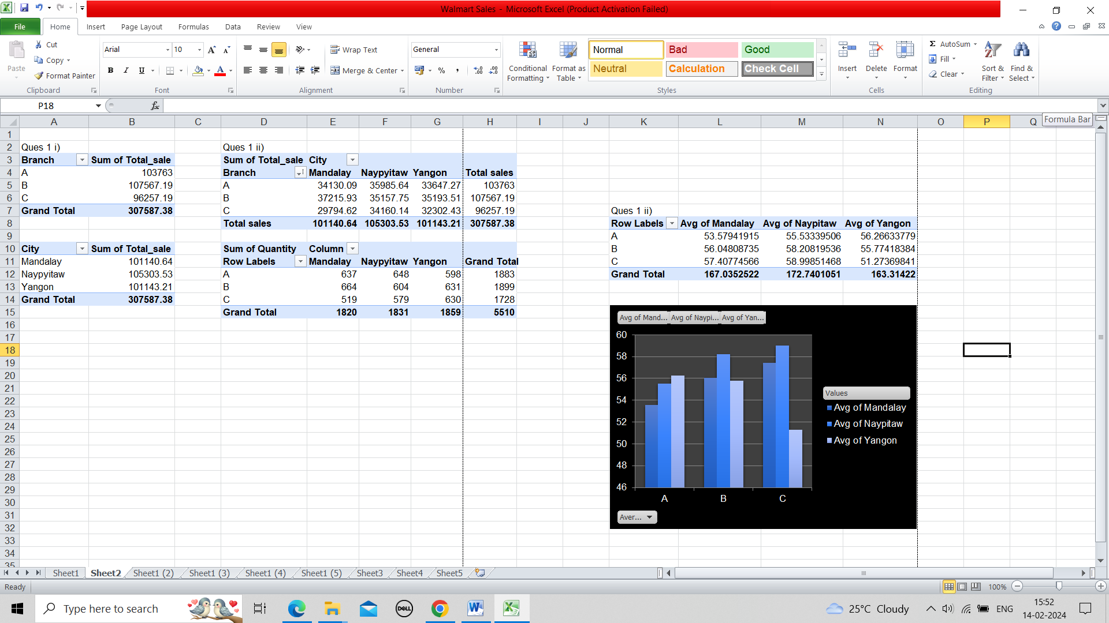

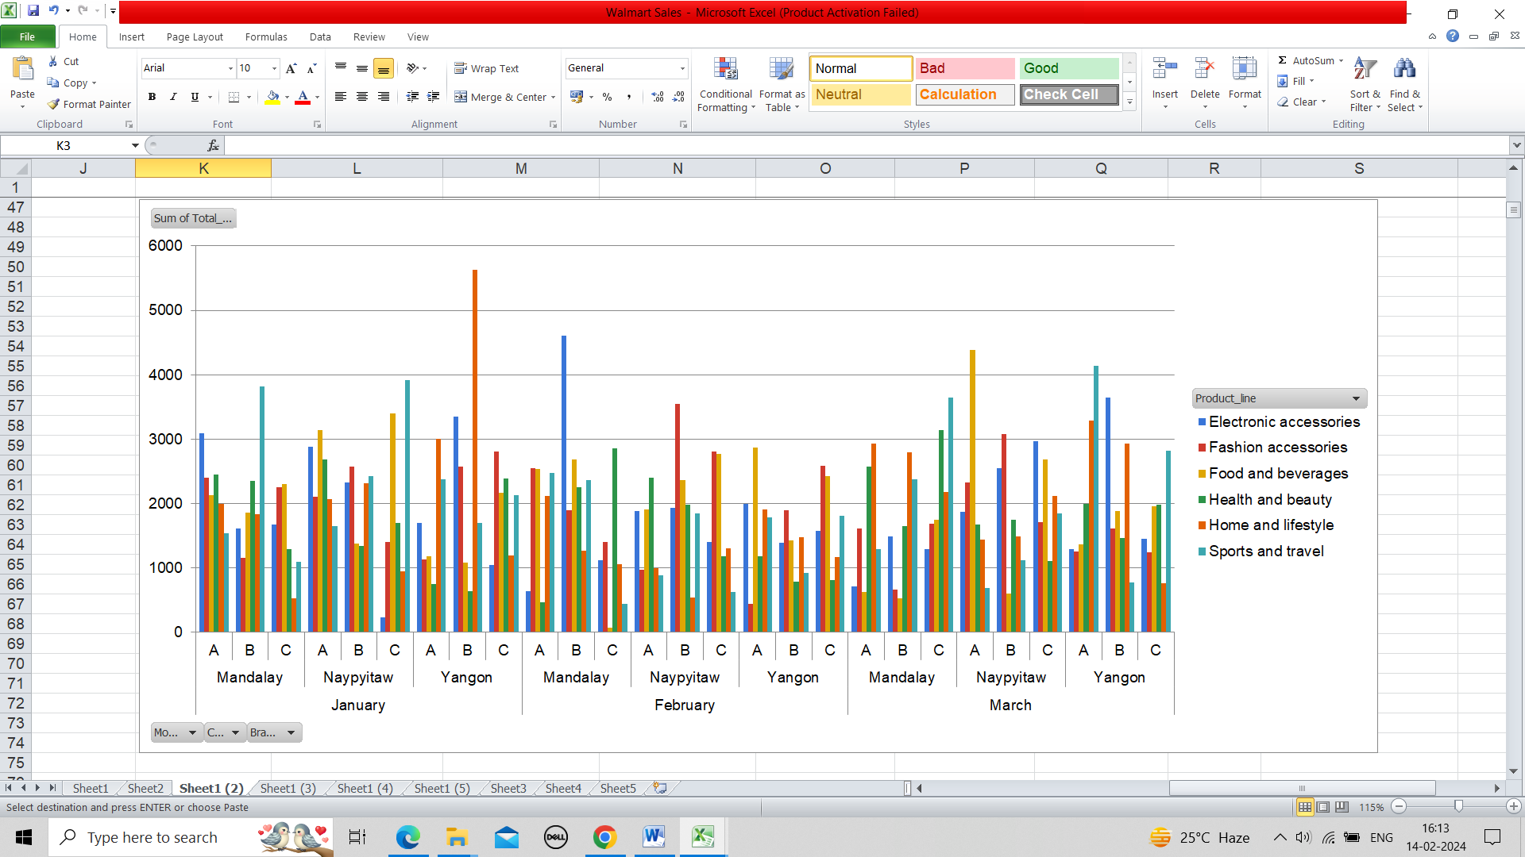

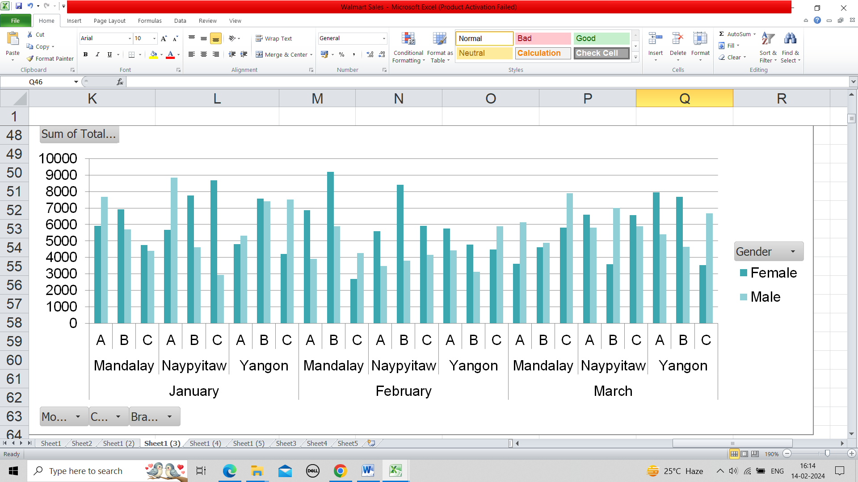

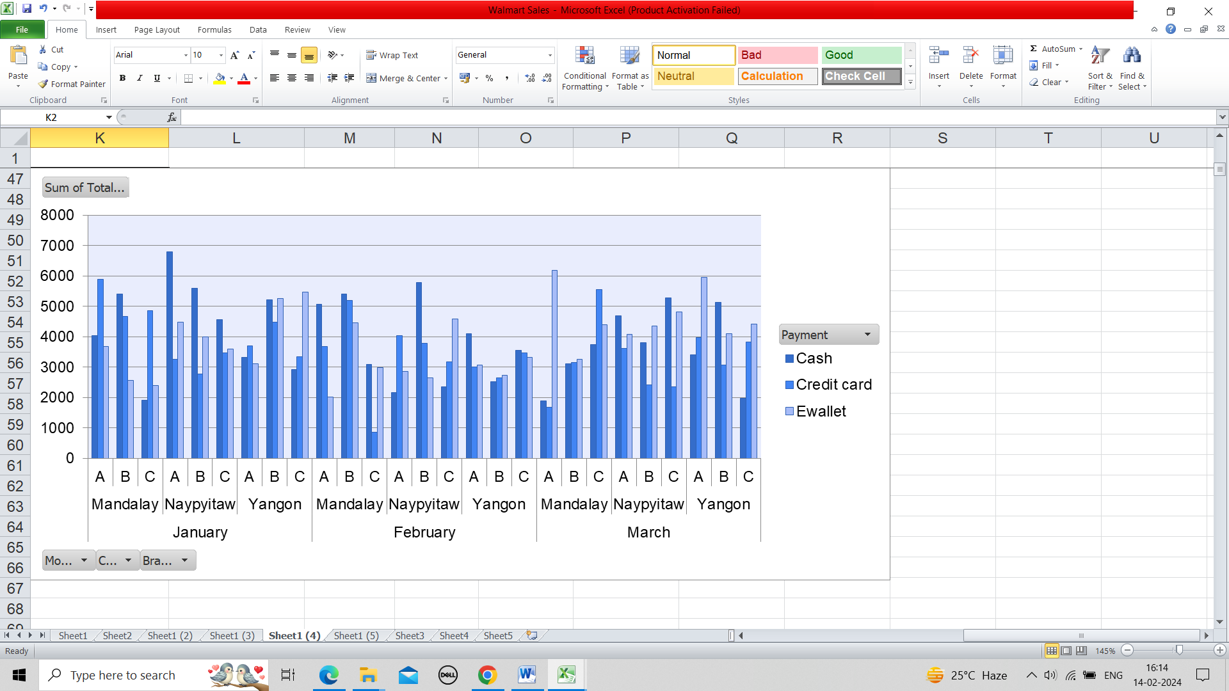

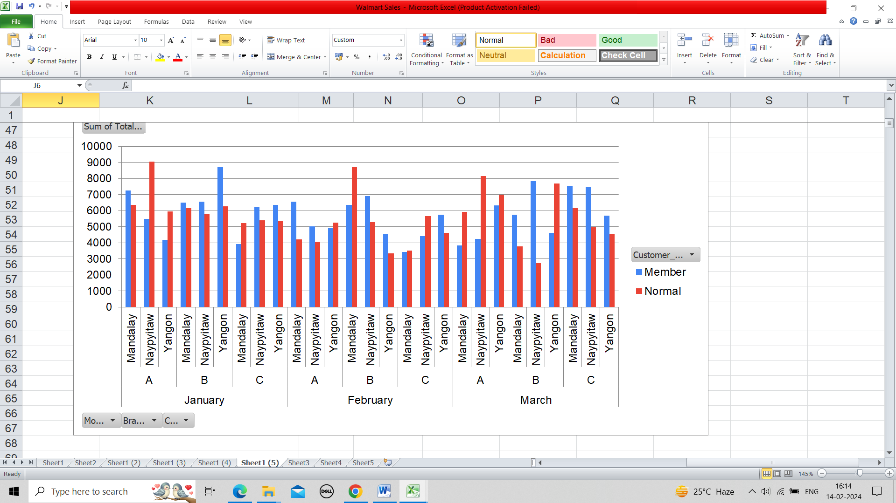

**c)**

* Product line – In product lines we need to focus on sales of health and beauty in all months as it shows the least sales amongst all other products. It could be improved through marketing in the zone where there are less sale.
* Gender - Majority in February and January we need to focus on Yangon and in March the sales are less in Mandalay.
* Payment- Payment is almost equal with all the methods of payment so there is no requirement for changes there.

Through this, we get to know the analysis that these areas need to be focused. The analysis is shown in the above link and snapshots of visualization.